1. **RTC:** 29940 - THCKSP: Shoprunner login in one store affects other two stores.

Steps to reproduce:

1. Launch the TH site
2. Navigate to any product details page and add the product to the cart
3. Navigate to Shopping bag page
4. Click on the shoprunner "Sign in" link in the body of shopping cart page.
5. Login with valid credentials
6. Launch CK and SP sites.
7. Add product to the shopping cart and navigate to the shopping bag page.

Screenshot 1:

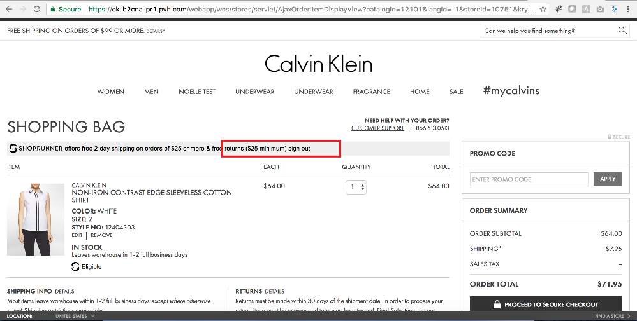

Screenshot 2:

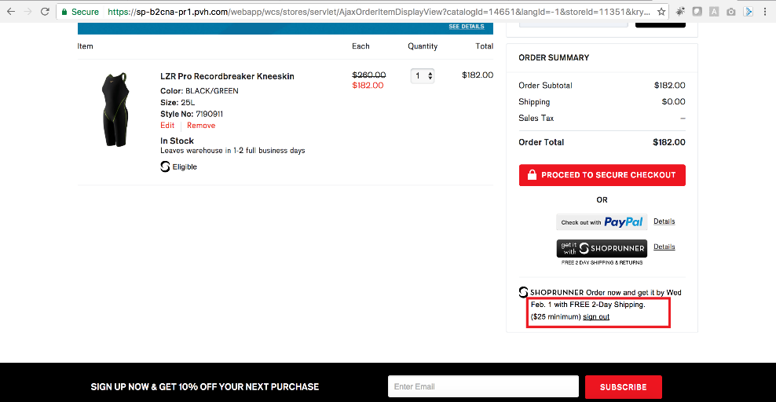

1. **RTC:** 29938 - THCK: "Continue shopping" button is not working.

Steps to reproduce:

1. Launch the THCK site
2. Add the product to the shopping bag and navigate to the "Shopping bag" page.
3. Click on the "Remove" link in the shopping bag page and wait for "Continue shopping" button to be displayed.
4. Click on the "Continue shopping" button.

Screenshot 1:

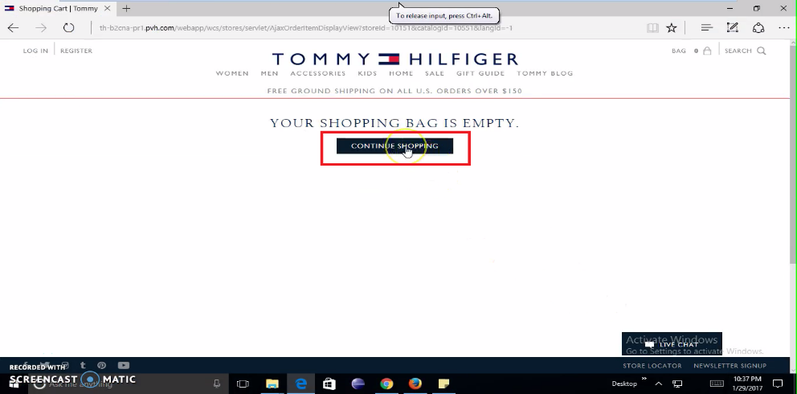

Screenshot 2:

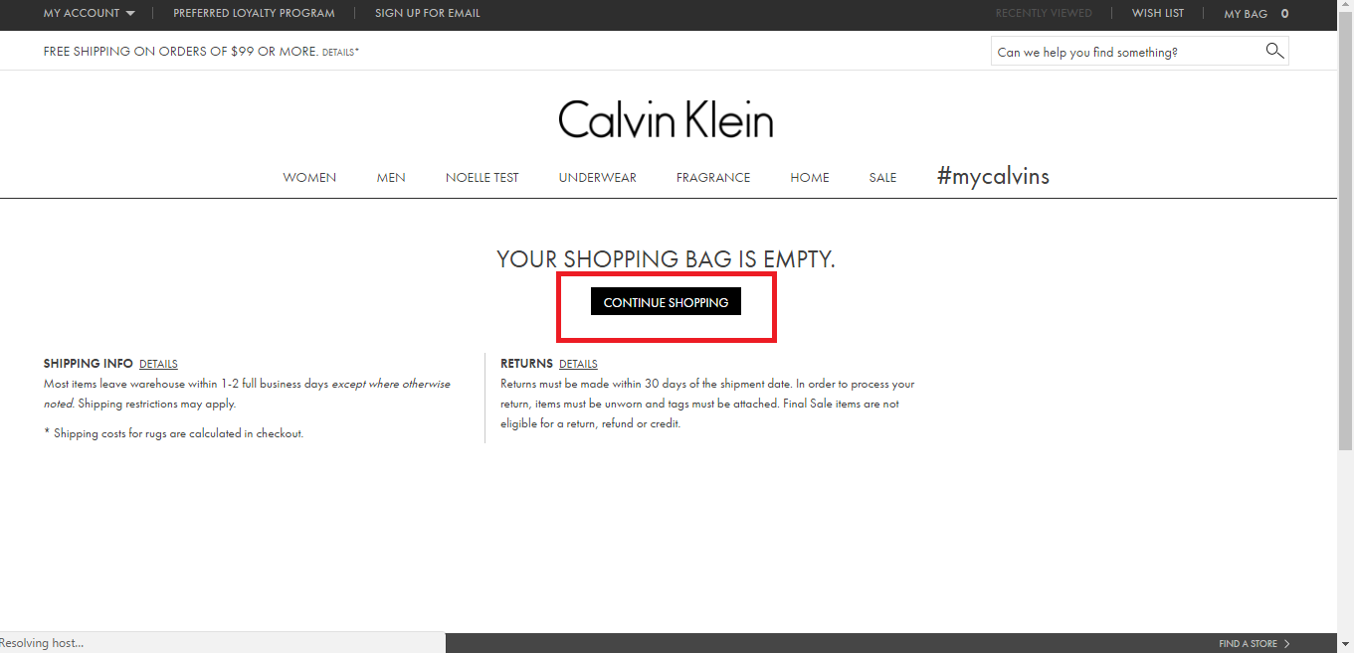

1. **RTC:** 29939 - THCKSP: Department header navigation is not working.

Steps to reproduce:

1. Launch the THCKSP site
2. Mouse hover on the top department header navigation.

Screenshot 1: 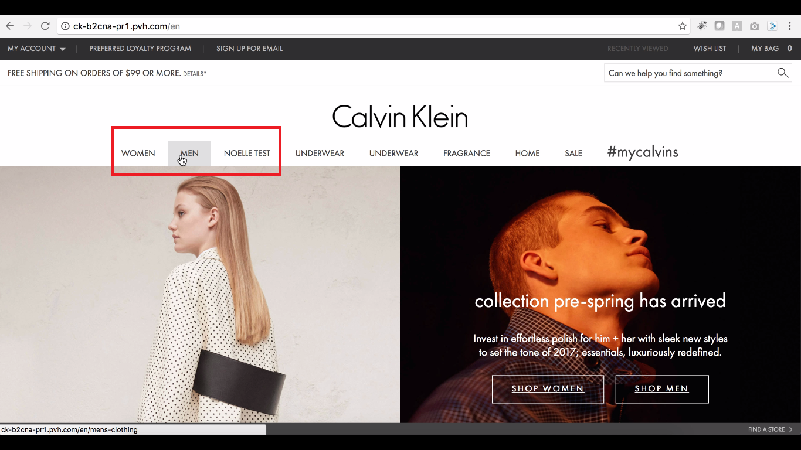

Screenshot 2:

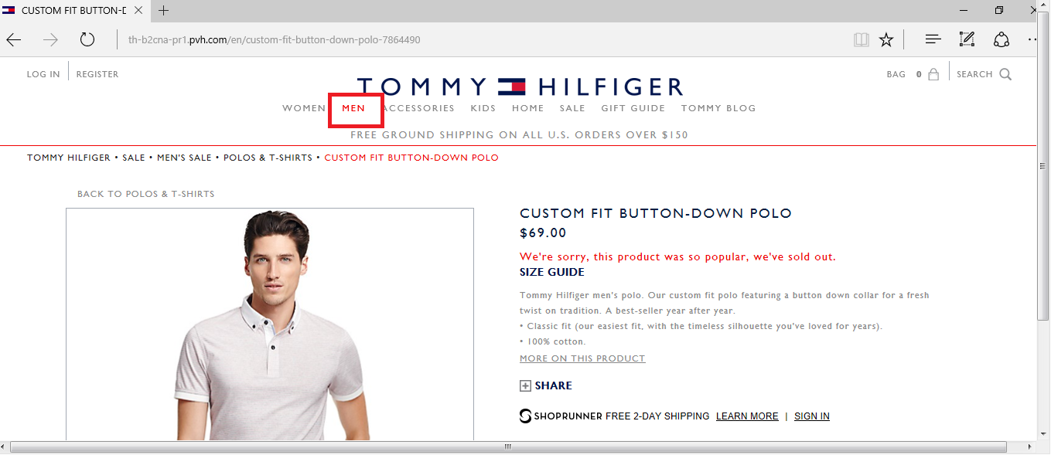

1. **RTC:** [29426](https://clm.siriuscom.com:9443/ccm/web/projects/PVH%20Projects#action=com.ibm.team.workitem.viewWorkItem&id=29426) - [CK : Click on "Edit" link in review order page navigates to 400 bad request page.](https://clm.siriuscom.com:9443/ccm/web/projects/PVH%20Projects#action=com.ibm.team.workitem.viewWorkItem&id=29426)

After click on “Review” Button

Steps to reproduce:

1. Launch the CK site
2. Login as registered user / Guest user.
3. Add a product to cart and navigate to shopping bag page
4. Click on "Proceed to checkout" button and navigate to shipping and billing page.
5. Fill all details in the "Shipping and Billing page" and click on "Review order button".
6. Page navigates to Review order / Order summary page.
7. Click on any "Edit" link in the review order page.

Screenshot 1:

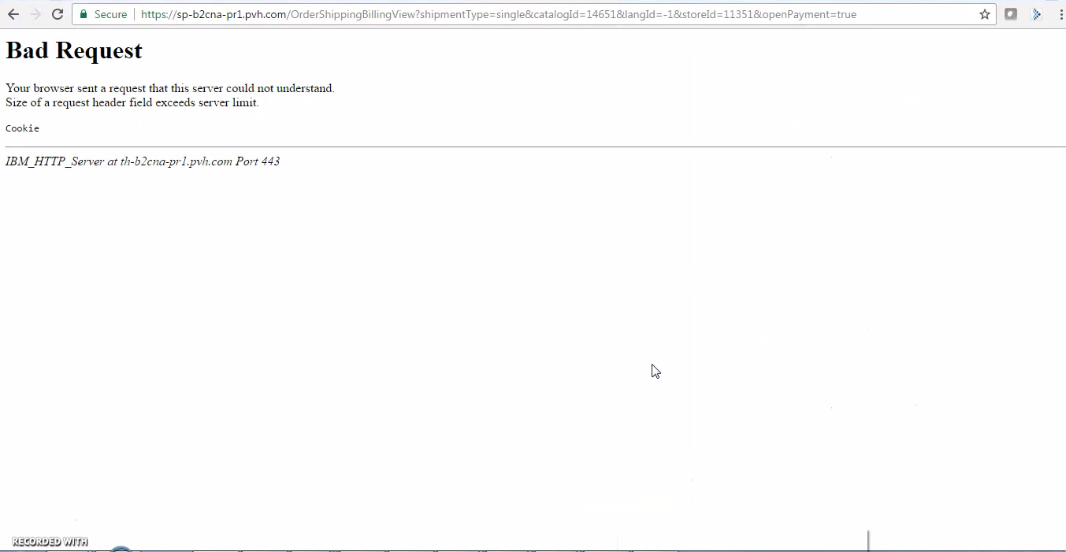

1. **RTC:** 29486 - THCKSP: User is able to place order without entering security code in credit card payment. (Only for: Master and Amex cards)

Steps to reproduce:

1. Launch the TH,CK,SP site
2. Add any product to the cart and navigate to shopping bag page.
3. Click on "Proceed to checkout" button in the shopping bag and navigate to the "Shipping and billing page"
4. Click on the "Continue" button in the guest user section.
5. Fill address, shipping method and navigate to the payment section.
6. In card type drop down select "Master card", enter the valid credit card number and click on the "Review order button".

Screenshot 1:

